Work Breakdown Structure
(WBS) Template

Outline View
The outline view presents an easy to view and understand layout for the WBS. It is also a good layout to use when developing the WBS because you can easily make changes, especially since the Microsoft Word auto numbering feature updates the WBS Code automatically.

- Widget Management System
  - Initiation
    - Evaluation & Recommendations
    - Develop Project Charter
    - Deliverable: Submit Project Charter
    - Project Sponsor Reviews Project Charter
    - Project Charter Signed/Approved
  - Planning
    - Create Preliminary Scope Statement
    - Determine Project Team
    - Project Team Kickoff Meeting
    - Develop Project Plan
    - Submit Project Plan
    - Milestone: Project Plan Approval
  - Execution
    - Project Kickoff Meeting
    - Verify & Validate User Requirements
    - Design System
    - Procure Hardware/Software
    - Install Development System
    - Testing Phase
    - Install Live System
    - User Training
    - Go Live
  - Control
    - Project Management
    - Project Status Meetings
    - Risk Management
    - Update Project Management Plan
  - Closeout
    - Audit Procurement
    - Document Lessons Learned
    - Update Files/Records
    - Gain Formal Acceptance
    - Archive Files/Documents

Tree Structure View (Graphical):

The Tree Structure View is the most popular format for the WBS. It presents an easy to understand view into the WBS; however, it is also tricky to create without an application specifically designed for creating this organizational chart structure. The Tree Structure below was created using only Microsoft Word and the SmartArt graphics option under the insert menu.

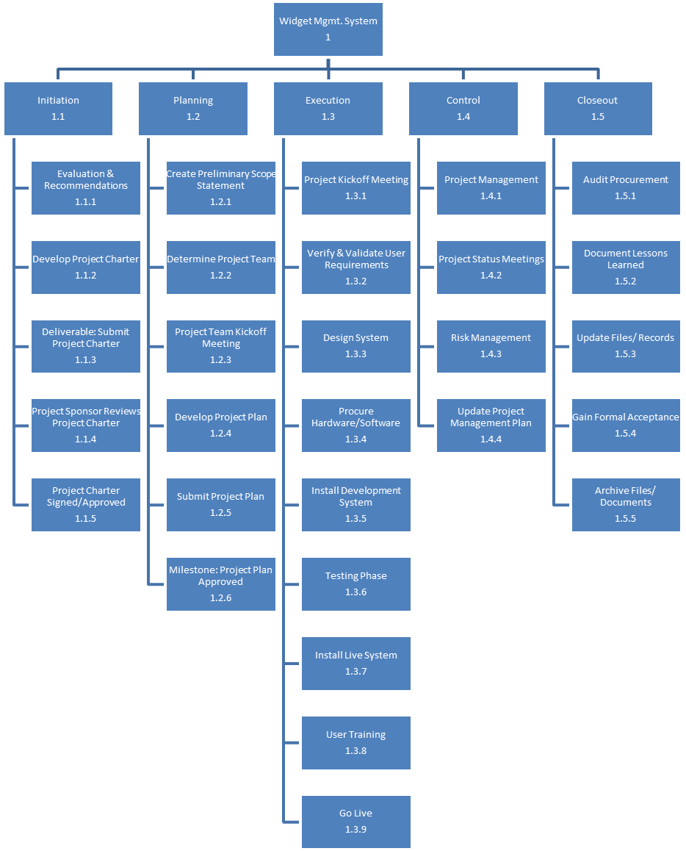

Work Breakdown Structure (WBS) Template
This Project WBS Template is free for you to copy and use on your project
and within your organization. We hope that you find this template useful and
welcome your comments. Public distribution of this document is only permitted
from the Project Management Docs official website at:

